|  |  |
| --- | --- |
| To: | Dr. Kaputa |
| From: | Jaric Sloan |
| Date: | 2/4/20 |
| Re: | Lab 1 |
|  |  |

Tech Memo

***Abstract:***

To build a functional GUI by using Pyqt and python to allow it to detect the various colors of the ball. The requirements are stated below.

* Shall be able to load in various images via a file menu
* Shall be able to select whether to detect a green or blue tennis ball
* Shall able to save various parameters used for tennis ball detection from a configuration file
* Shall display the X and Y values of the centroid of the detected tennis ball

***Introduction:***

By meeting the goals of the requirements, the sample code was provided to analyze and improve the GUI experience and add more features to enable the users to choose whether they want to detect the green or blue tennis ball. Also, to identify the location of the ball by using the centroid of the detected tennis ball.

***Hierarchy and organization of codebase:***

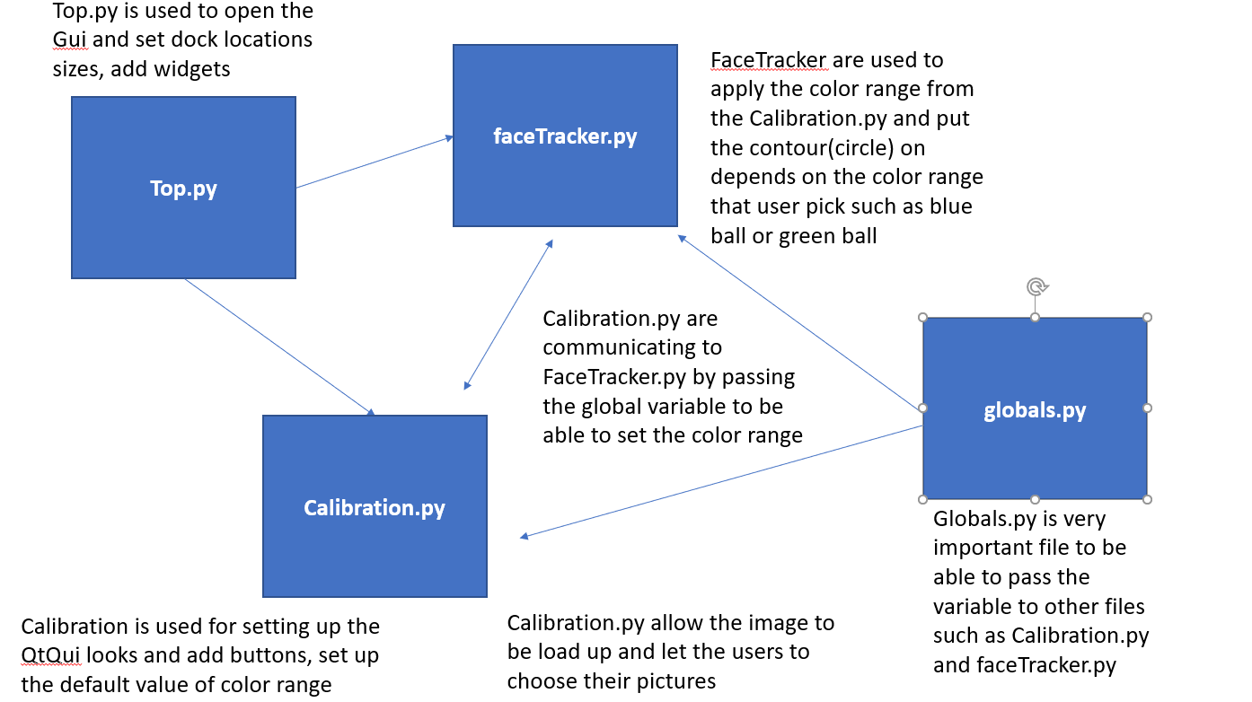

As shown below in globals.py, it is very important to have that file since it is used to communicate with faceTracker.py and calibration.py. The global variables are passed to two files and without globals.py it would not function properly. To use the global.py other files must have "from globals import globals" on the top of the code.

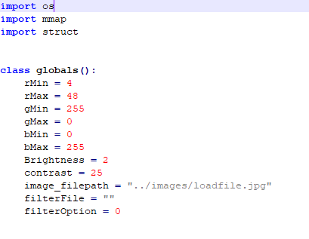

Figure : defaults settings

**Calibration.py**

This section is used to create one of the sliders for GUI named rMin and by using this code can be created to make other sliders similar but change the variables.

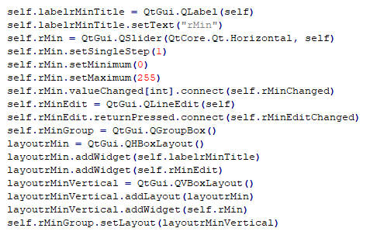

Figure : sliders to adjust colors range

This section is used to create one of the buttons for filter activation. This code also creates a button for load image, load file and save the file.

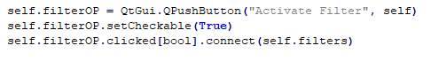

Figure : Set button to confirm if the button is pressed

This section is used to avoid the minimum and maximum values from interfering with each other. It helps the cv2 to be able to read the color range of minimum and maximum values.

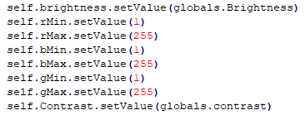

Figure : set the default values to avoid cv2 color range error

In this section, the filter button has its function to be able to do something once it is pressed. When the sliders are set by the user's preference and press the filter activation button to detect the tennis ball depends on the settings of the sliders.

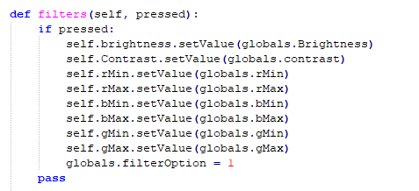

Figure : to determine the button is pressed and if it is then set the values of the color range sliders

This section shows that when the button is pressed it will read the value from the blue detection text file and set them up on the sliders. It won't show immediately since the "activate the filter" button need to be pressed to make it work.

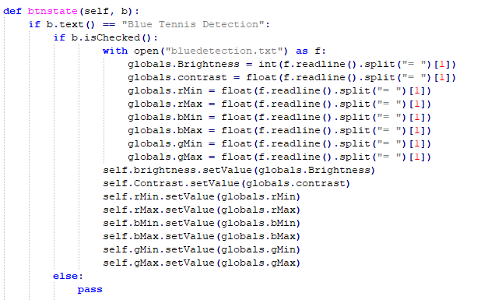

Figure : Reading the sliders values from the text and assign the values to the sliders

This section shows that the users will pick their images in the folder path and it won't open anything else than jpg files. Also, when the users adjust the sliders and they can save the configuration file by clicking the save file button.

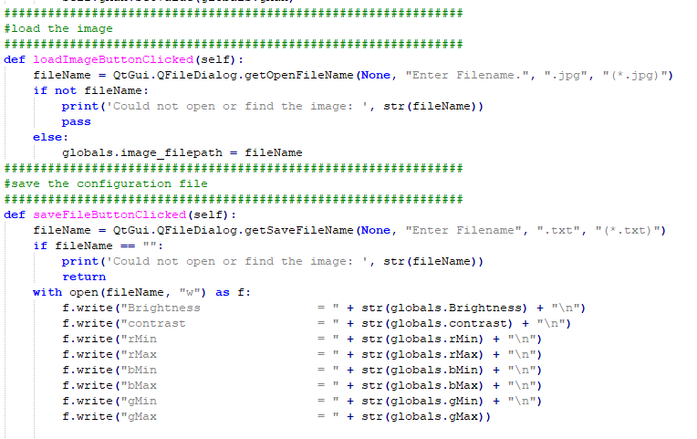

Figure : To allow the users to pick any images, allow them to save the configuration file

**faceTracker.py**

In this section, it takes the global variables from the calibration.py and be able to open the file location where the image folder is located. It also enables the users to choose any images they want, and it is in a timer event that will keep running.

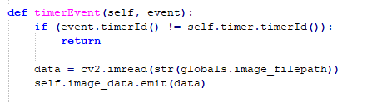

Figure : While on timerEvent it will continue to run and keep the image open

This section with two photos shows that faceTracker.py is getting the global variable from the calibration.py and depends on the sliders of the GUI. As shown in the lower and upper, they are for the lower color range and upper color range. After that code, it will try to find the specific color and the circle will appear on the ball by using the code "if statement for lens & radius. By using lens and radius code, it will show the X and Y coordinates on the image and the circle included. Self.image = self.get_qimage(clone_img) means once the activate filter button is clicked it will change to a similar image but with the x and y coordinate include the circle.

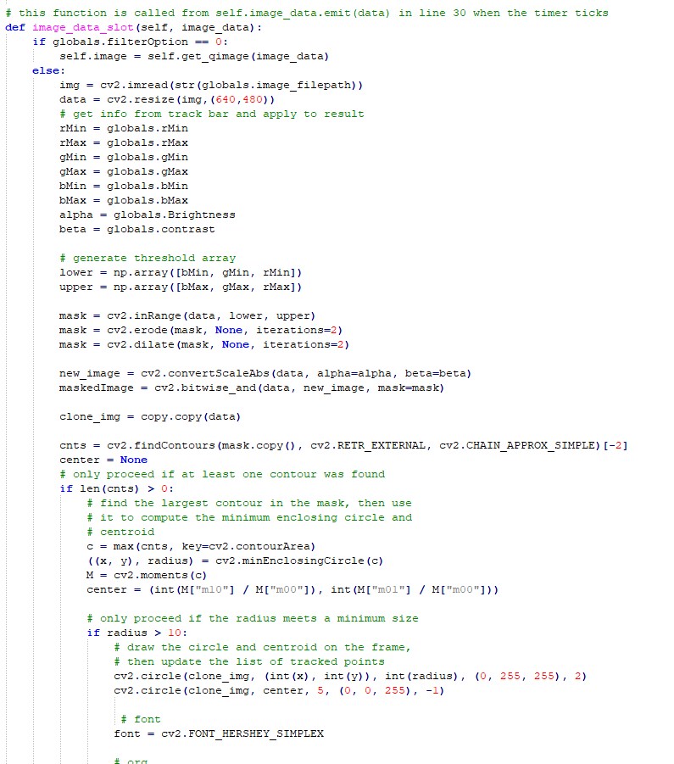

Figure : Get the values of the global variables from the calibrations and allow them to be set through the color range to be allowed to detect the color of the tennis ball and put a circle on it

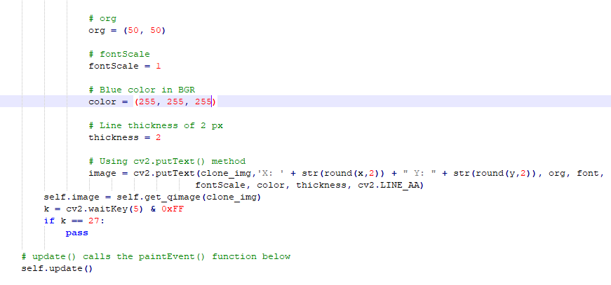

Figure : To get the coordinate of the x and y, then put those numbers on the left corner on the images.

**Top.py**

Top.py are the top architecture of the entire files and top.py are the file we want to run. As shown below, it is shown that it will run all files such as faceTracker, calibration, and global. Top.py is running the dock locations of the GUI.

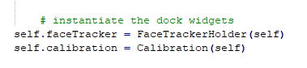

Figure : To run the faceTracker and calibration.

***Conclusion:***

The lab of this assignment is considered a success since the error of color range that cv2 did not understand is already resolved by inserting default values as shown in Figure 4.